Extra Credit 14

In a prison, there is a door b/w any pair of adjacent cells and one exit guarded by a guard G. One prisoner is a maniac M which kills anybody he can see when he enters a cell. If M returns to the cell with his victim, then he loses consciousness and stops. In the evening all inmates and the guard went to sleep in their cells. In the morning, maniac M is gone and all other prisoners with the guard were found dead in their cells. Show the route of the maniac.

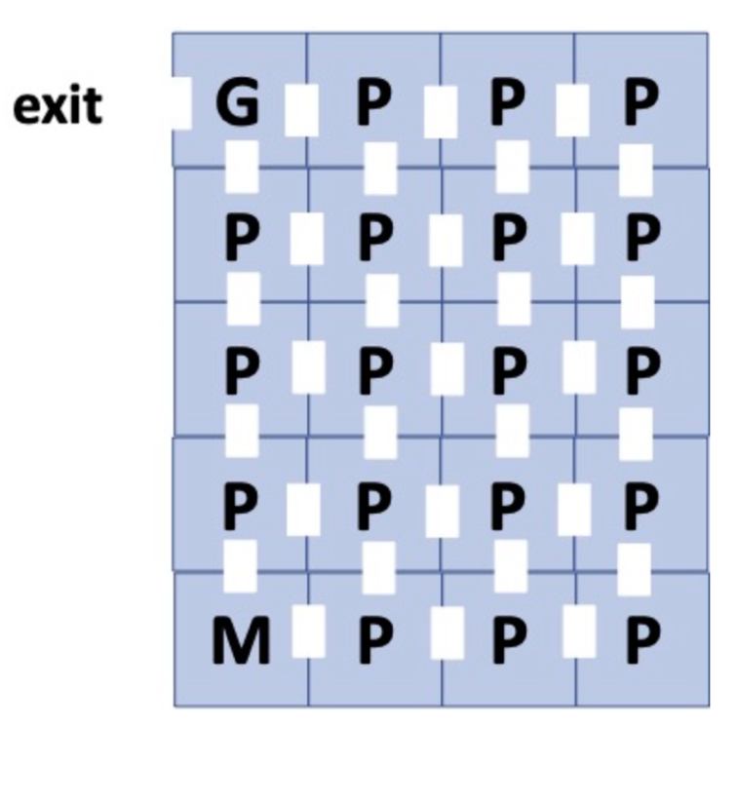

The trick here is that the maniac can go on his adjacent cell, kill its prisoner, and move back to his own cell and then go to another adjacent cell and then continue to move ahead.

To simplify the concept and to have a better understanding, lets number all of the cells as marked in the attached picture.

Initially, the Maniac is in cell 17, he goes to cell 18 and kills its prisoner, and then comes back to cell 17, then moves to cell 13, and then follows the below mentioned sequence.

17 -> 18 -> 17 -> 13 -> 14 -> 15 -> 19 -> 20 -> 16 -> 12 -> 11 -> 10 -> 9 -> 5 -> 6 -> 7 -> 8 -> 4 -> 3 -> 2 -> 1 – EXIT

